

Vrinda Stores sales Data Analysis (Interactive Dashboard creation using MS Excel)
Case Analysis Report

NAME | ID
Anirban Paul | C.ID-CSIP15395

Vrinda Store Data Analysis (Interactive Dashboard creation using MS Excel)

- Problem Statement

Vrinda Store operates a multi-channel e-commerce business, generating continuous transactional data across various demographics, product categories, and sales platforms.

- The Problem

Despite accumulating substantial sales data, the business lacks clear, consolidated visibility into key performance drivers and customer purchasing behaviors. This fragmentation of data makes it difficult to pinpoint which demographic segments (e.g., Men vs. Women) are driving the most revenue, which sales channels are the most lucrative and which product categories require inventory optimization. Consequently, marketing and sales strategies are currently driven by intuition rather than empirical data leading to potential inefficiencies in resource allocation.

- The Objective

The objective of this project is to clean, analyze and visualize the annual sales data to uncover hidden trends in consumer behavior and product performance. By developing an interactive dashboard and extracting key metrics (such as Average Order Value and channel-specific revenue), this project aims to provide stakeholders with data-driven insights to optimize targeted marketing campaigns, streamline inventory and ultimately maximize overall revenue for the upcoming fiscal year.

- Dataset Used:
https://docs.google.com/spreadsheets/d/1GUSVvhN7d07C0AezJtaWGzeHyntpTvLc/edit?usp=sharing&ouid=110654712277101350763&rtpof=true&sd=true

Questions (Key performance Indicators):

- Compare the sales and orders using a single chart.
- Which month got the highest sales and orders?
- Who purchased more – Men vs Women ?
- What is different order status in 2022?
- List top 5 states contributing to the sales.
- Relation between age and gender based on number of orders.
- Which channel is contributing to maximum of the sales.
- Highest Selling Category?
- Calculate basic sales metrics like total revenue, average order value, and total sales.

- Visualize trends using basic line and bar charts (e.g., monthly sales trends).
- Identify the top 3 products by sales and visualize them in a bar chart.

Insights:
1.

The bar graph represents total monthly sales revenue, while the overlaid line graph tracks the number of monthly orders. Both metrics closely follow each other, indicating a direct correlation, peaking sharply in April.

2.

March recorded both the highest sales and the highest number of orders. During this peak month, the store generated ₹1,928,066 in total revenue from 2,599 unique orders, outperforming all other months significantly in the dataset.

3.

Women purchased substantially more than men. Female customers accounted for over 19,900 orders and generated around ₹13.5 million in sales revenue. In contrast, male customers contributed only about 9,100 orders, resulting in roughly ₹7.6 million in total sales.

4.

For orders placed in the year 2022, the dataset tracks four distinct order statuses. These statuses are: "Delivered" for completed shipments, "Refunded" for money returned, "Cancelled" for aborted orders, and "Returned" for items sent back by the customer.

5.

The top five states contributing to the highest sales revenue are Maharashtra (₹2.99 million), Karnataka (₹2.64 million), Uttar Pradesh (₹2.10 million), Telangana (₹1.71 million), and Tamil Nadu (₹1.67 million), indicating strong market penetration in these regions.

6.

Across all age brackets, women consistently place more orders than men. Female adults form the largest demographic, contributing roughly 10,200 orders. Female teenagers follow with over 6,400 orders, significantly outpacing male adults, who placed only around 4,750 orders.

7.

Flipkart is the top-performing sales channel, contributing the maximum revenue to the business. It generated ₹7,519,933 in total sales, making it the most lucrative platform for Vrinda Store compared to other e-commerce channels like Myntra or Ajio.
8. 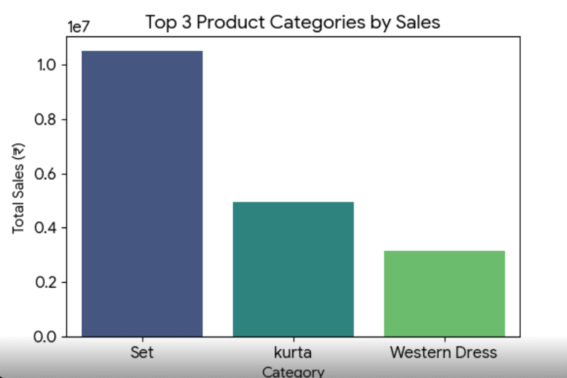

The highest-selling product category is "Set". It vastly outperforms all other clothing items in the catalog, bringing in a total revenue of ₹10,507,546. This indicates a strong consumer preference for matching outfit sets over individual apparel pieces.

9. Calculating basic sales metrics:
i) Total Revenue: Use the SUM function on your Amount column.
Formula: =SUM(Amount_Column_Range) (e.g., =SUM(F:F)) = Rs 1226250

ii) Total Orders (Total Sales): If every row is a unique order, you can just count the rows. If one Order ID can span multiple rows, count the unique IDs.
- Formula (Unique Orders): =COUNTA(UNIQUE(Order_ID_Column_Range)) - 1
= 1/0/1900

iii) Average Order Value (AOV): Divide the total revenue by the total orders.
Formula: =Total_Revenue_Cell / Total_Orders_Cell (or simply use =AVERAGE(Amount_Column_Range) = 12/21/1901

10.

PivotTables are the most efficient way to group your data by month and chart it.
- Insert a PivotTable: Select all your data. Go to Insert > PivotTable and place it on a New Worksheet.
Build the PivotTable:
- Drag your Date (or the new Month) field into the Rows area.
- Drag the Amount field into the Values area. (Ensure it says "Sum of Amount". If it says "Count", click it, go to Value Field Settings, and change it to Sum).
Create the Line Chart: Click anywhere inside this new PivotTable.
- Go to Insert > PivotChart and select a Line Chart.
- Format the chart by adding a title like "Monthly Sales Trends" and hiding the field buttons for a cleaner look.

11) Identify & Visualize the Top 3 Products by Sales

- Insert a New PivotTable: Go back to your main data sheet, select all data, and go to Insert > PivotTable.
Build the PivotTable:
- Drag Category (or Product Name/SKU) into the Rows area.
- Drag Amount into the Values area (again, ensure it is set to "Sum").
Filter for the Top 3:
- In the PivotTable, click the drop-down arrow next to Row Labels.
- Hover over Value Filters and click on Top 10...
- Change the "10" to a "3" and click OK. The table will now only show your three highest-grossing products.
Create the Bar Chart:
- Click inside this filtered PivotTable.
- Go to Insert > PivotChart and select a Clustered Column (Bar Chart).
- Right-click the bars on the chart and select Add Data Labels so the exact revenue figures appear above each product.

Final Dashboard Using Excel Pivot tables and Slicers:

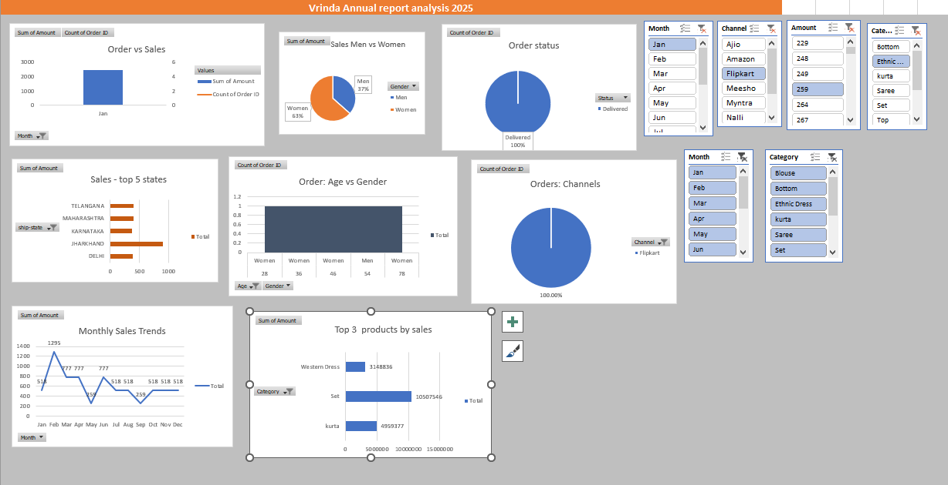

Conclusion:
- Women customers are more likely to buy products compared to men (~65%).
- The states of Maharashtra, Karnataka and Uttar Pradesh are the top 3 product buyers.
- The adult age group (30-49 yrs) is max contributing (~50%) and buys the most products.
- The maximum number of products customer orders from Amazon, Flipkart and Myntra channels.

Final Thoughts:
To improve sales of Vrinda Store, women customers of the age group (30-49 yrs) living in Maharashtra, Karnataka and Uttar Pradesh must be targeted by showing ads/offers/coupons available on Amazon, Flipkart and Myntra.

